PART Questions
Student Name
Institutional Affiliation
Date of Submission

PART Questions
PART 1 - Operations Assignment
1. Five forces is a framework for analyzing the competitive environment of the company
2. Outsourcing is an agreement where a company hires another company to be responsible for an activity that is in existence that is done internally.
3. Brick and mortar may refer to a traditional street-side business which offers both products and services to its customers individually in an office that the business owns.
4. Strategic positioning is the act of establishing a business where all factors are looked at or where it fits.
5. System approach is a line of thought in the field of management that emphasized the interactive nature and interdependence of both internal and external factors in an organization.
6. Logistics is a commercial activity for transporting goods and customers.
7. Operations management is the administration of business practices to create the highest level of efficiency possible in an organization.
8. Dematerialize means to lose or lose materiality.
9. Inductive reasoning is a type of reasoning in which the premises are perceived as delivering some evidence for the truth of the consensus.
10. Service concept analyses the how and the what of the service design and assist in mediating between the needs of the customers and the firm’s strategic intent.
11. Decouple means to disengage or dissociate from something else.
12. Experience economy is an economy where many goods and services are sold by stressing the impact they can have in the life of people.
13. E-commerce involves placing orders of goods and paying online while E service is a service that use information and communication technology.
14. TQEM is a business management practice that prevent environmental pollution that is attained through Total Quality Management techniques.
15. Roll up means to acquire through successive accumulations.
16. Esthetic is being beautiful or the appreciation of beauty.
17. Escapist is someone who wishes or dreams but doesn’t live in the actual world.
18. Offshoring is the relocation of a process of a business from one country to another.
19. Tactical execution deals with the circumstances firms or organizations are facing.
20. DEA is a method in operations research and economics that is used to estimate production frontiers.
PART 2 - Homework Exercises
1. Supply chain deals with receiving product from the suppliers and reaching in final destination. The formats of supply chain are the manufacturers, warehouses and stores so that merchandise is produced and distributed to the correct locations at the right time. Value added refers to increase in value of an item or commodity after some stages. Healthcare supply chain management entails getting resources, handle the supplies and delivering goods to patients. Healthcare agencies are able to place orders on the right size of products from the industry.
2. There are four characteristics of service industries which include; intangibility, inseparability, perishability and variability. The healthcare industry can be categorized as service industry since it meets all of the above features of a service industry.
Comparison of manufacturing and service operations
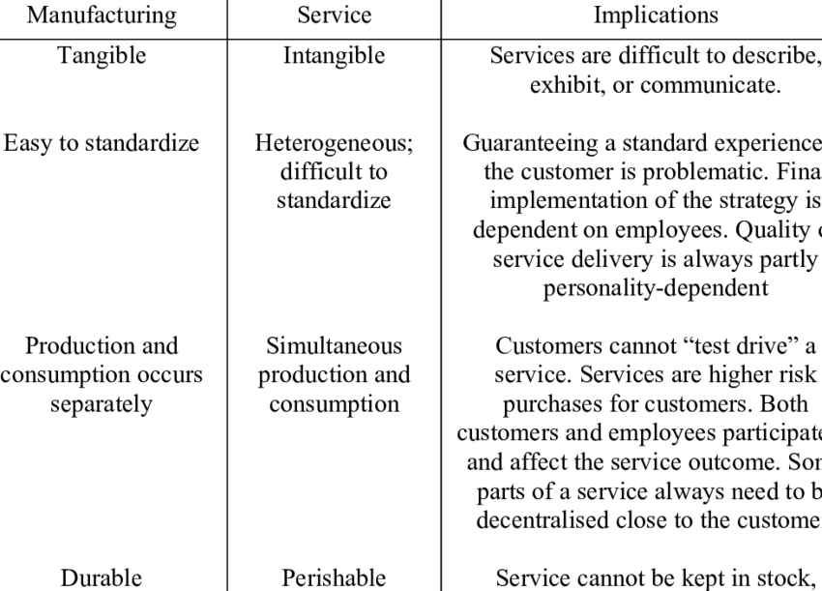

3. There are a number of factors considered when designing the operation system:
Location: In developing a location strategy it is important to consider the supply chain and how the location will get the supplies, the movement of goods and services both internally and to customers. The healthcare operation system should be designed where customers can reach and patients access with ease.
Supply chain management: Determine the best techniques to supply and should be cost effective and to get trusted partners.

Quality management: be clear on the needs of the customer and also meet the objectives or expectations. There should also be the use of research in order to understand the needs of the customer and apply quality assurance on the services in production.
4. In order for a product to have a competitive position t has to be based on two dominant dimensions: Price is one of the strategy and in this case the price of a product affects the competitive position of the product. High priced products have low competitive advantage in the market unlike those on low prices. The value of the product is primary in its competitive area in the market. Products that are of high value are quickly acquired by customers since they are of high quality. I would support on the value of the product because certain products with high prices can easily be bought by customers than of low price and low value.
5. Customer utility model is a right granted for an intervention that allows the right customer to restrict others from using the protected invention. Blueprinting is a process chart that shows the delivery of services from the customer’s view.
6 841*7-58*7=5481*5%
=274
7. Centralize the back-office work on a regional basis.
Reward the workers in the back- office based on the quality of the work.
Engage the chosen workers to resolve difficulties and back-office workers.
8 Efficiency=weighted sum of output/ weighted sum of input
Eff. of B= 350/310=1.129
Eff. Of E=380/390=0.974

9 System analysis may not fit the use for service industry. This is because service industry is intangible which does not feature in this step of System Approach.

